**Greek Myth**

**BACKGROUND NOTES**

Myths are stories that are not necessarily true; they were fiction but could have some basis in real life events. They were everywhere in the ancient Greek world, and they continue to be popular today. We know about Greek myths from ancient writers and from works of art such as painted pottery decorated with scenes from mythical tales (e.g. the Labours of Herakles).

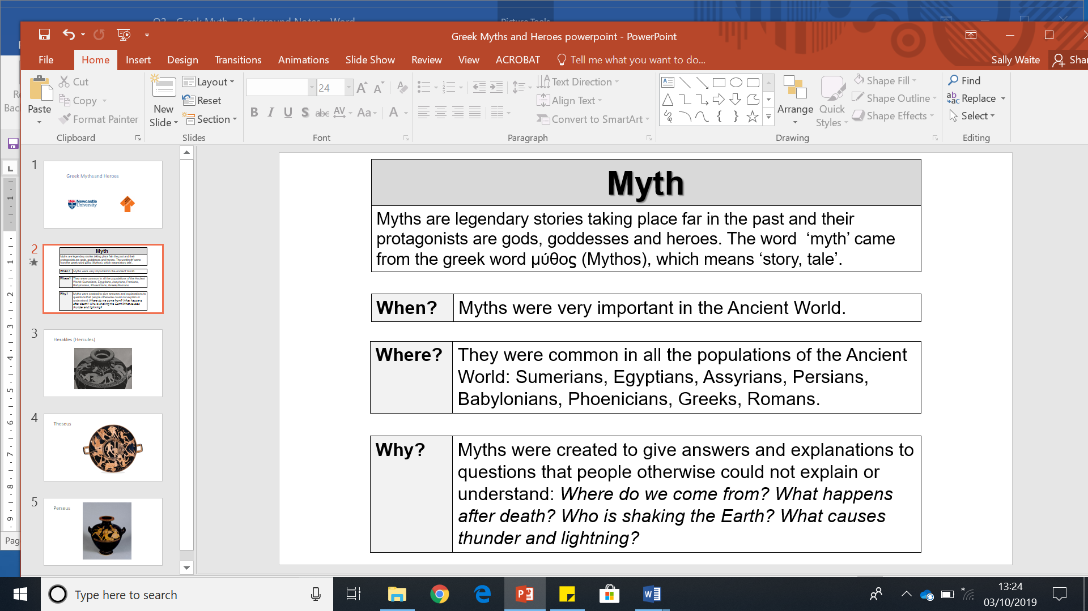

Greek myths encourage us to think about human actions and emotions and the effects that those can have. Myths are a way to express human thoughts and fears. Myths are different from history because they are not tied to specific times, places or events. Hence the universal appeal of ancient Greek myths.

Every mythical story had a whole range of different versions in ancient Greece. The earliest versions of myths come from the oldest pieces of epic poetry, which were sung by travelling performers for a long time before they were written down. The ancient Greek poet Homer composed mythic stories about Troy (The Iliad) and Odysseus/Ulysses (The Odyssey) between 750 and 650 BC.

Many ancient Greek myths were stories used to explain past events or things people did not understand. They could also be used to serve as lessons. One well-known myth is the story of Pandora. This is a useful myth to explore the concept of dilemmas:

**Pandora**

* Pandora was the first human woman
* She was made by the god Hephaestus, upon the orders of Zeus
* The myth of Pandora was used to explain why there is evil in the world
* Pandora was given a pithos (a storage jar) that is now known as ‘Pandora’s Box’
* Pandora’s Box contained evil; because it was in the Box, it was kept from the world
* Pandora was told not to open the Box, but could not resist; because she opened the Box she allowed evil into the world

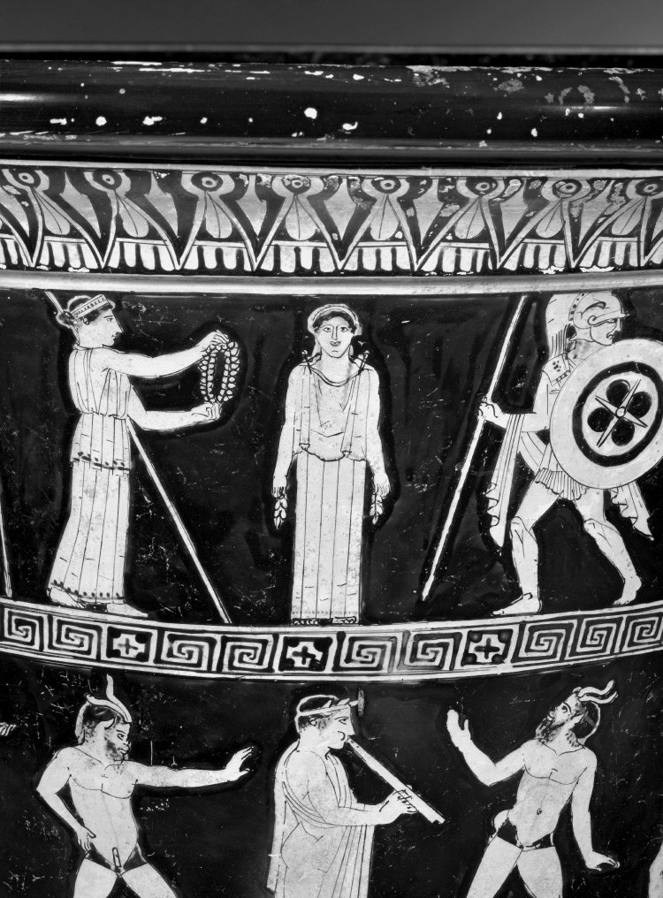

This red-figure pot from the British Museum shows the making of Pandora. Pandora stands in the centre and looks out at the viewer. Athena stands to the left of Pandora and holds out a wreath to her. The god of war, Ares, stands to the left of Pandora, dressed in his armour and carrying a spear and shield.

Ancient Greek myths often have a hero who has to undertake special (and usually dangerous!) tasks. These heroes can be compared to modern superheroes. Some of the best-known of these heroes are Herakles, Theseus and Perseus:

**Herakles**

* Herakles is the greatest of all Greek heroes
* He was the son of Zeus and had a mortal mother, Alkmene
* The goddess Hera did not like Herakles from the very beginning. When Herakles was a baby Hera sent snakes to attack him in his cradle but Herakles strangled them
* Herakles is famous for his twelve labours
* Athena often helped Herakles
* When he died he went to Mount Olympus and became immortal
* Herakles is identified by his lion skin cloak, club, bow and arrows
* The Romans knew Herakles as Hercules



On this pottery red-figured hydria (water-jar) made in Athens in the fifth century BC Herakles is represented strangling the Nemean lion. This is the first of Herakles’ famous labours and provides him with the lion skin that he often wears. Herakles wears no clothes and he is wrestling with the lion. Athena is on the right and a warrior on the left. He has a sword on a belt and his cloak is hanging on the tree behind. Athena wears a long chiton (dress) and a mantle (cloak) and holds a shield (device: a snake). Once Herakles has killed the lion he uses one of its claws to skin it.

**Theseus**

* Theseus is a mythical Athenian hero
* Theseus was the legendary king of Athens
* Like Herakles, Theseus had many adventures, indeed the two heroes had some adventures together
* Theseus’ most famous battle is with the Minotaur on the island of Crete
* Athena supports Theseus in his deeds
* Theseus is represented as a youth and often wears the clothes of a traveller the sun hat (petasos)



On this pottery red-figured drinking cup (for wine) made in Athens in the fifth century BC some of Theseus’ deeds are represented. In the centre we see the youthful (he has no beard) Theseus with a sword in his hand dragging the Minotaur from a building.

**Perseus**

* Perseus is famous for killing the Gorgon Medusa
* He was son of Zeus and a mortal woman, Danae
* He rescued Andromeda from a sea monster
* His mortal grandfather believed he would be killed by Perseus, so he put Danae and the baby Perseus into a chest and threw it into the sea; they survived because the chest wash washed up on the island of Seriphus

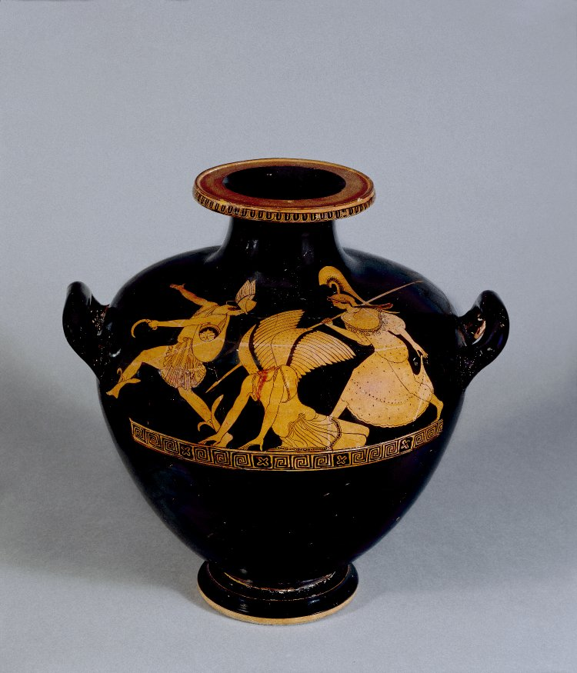

On this pottery red-figured hydria (water-jar) made in Athens in the fifth century BC Perseus has just cut off the Gorgon Medusa’s head. Medusa the winged figure (with no head) is in the centre. Perseus runs off to the left looking back, he wears a short chiton (dress), winged sandals and winged hat. He carries a knife in one hand and over his shoulder he wears a bag with the head of the gorgon and he holds a knife. Athena follows, carrying a long spear. She wears a long chiton (dress), aegis fringed with snakes and a helmet.

**Have a look at this vase animation:** <http://www.panoply.org.uk/medusa.html>

**Jason**

* Jason is most famous for his epic sea voyage on his boat the Argo with the Argonauts
* He was the rightful King of Iolkos
* He went on a quest to find the Golden Fleece for Pelias, the King of Iolkos who wanted Jason out of the way so he could keep his throne
* The Golden Fleece was from a winged ram created by Zeus
* The witch Medea fell in love with Jason and helped him to take the Golden Fleece from her father
* Jason eventually came to rule Iolkos, but was killed when his boat, the Argo, fell on him

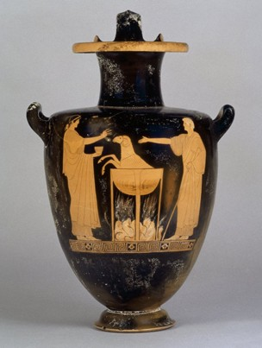

This red-figure hydria (water jar) from the British Museum was made in Athens in the early fifth century BC (around 480 BC). It shows Jason, to the right, and his wife Medea. Medea is working her magic so that a ram can be made young again. Some stories tell that Medea tricked the daughters of Pelias – who had stolen Jason’s throne – into killing Pelias by encouraging them to try a similar spell on him so he would be made younger. Instead, they murdered Pelias because one of the parts of the magic spell involved cutting him into pieces. With Pelias dead, Jason reclaimed his throne, becoming King of Iolkos.